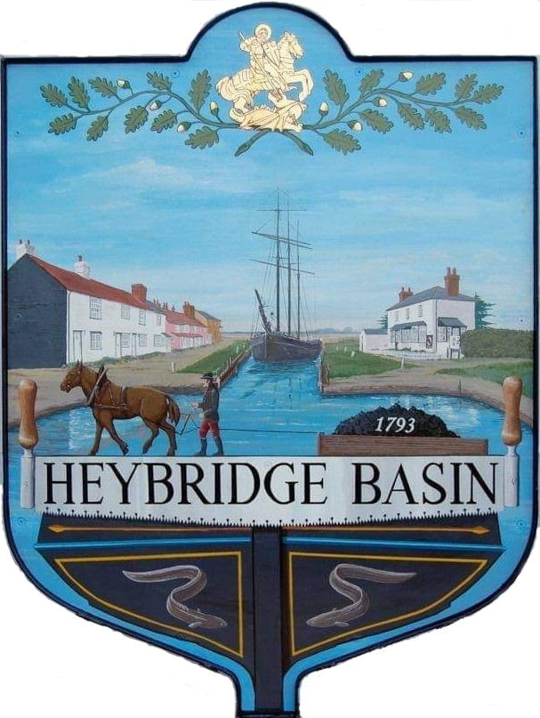

HEYBRIDGE BASIN PARISH COUNCIL

Minutes of the Extraordinary meeting of Heybridge Basin Parish Council held on Monday 5th February 2024 at 12.30pm, at St George’s Community Room.

PRESENT

In the Chair: R. Bryson (Vice) Absent: 0

Councillors: C. Edmond Apologies: 3
M. Hobden
G. Howat Public: 16
C. Swann

Officers: G. Lake – Clerk District Councillors: P. Spenceley

In the absence of the Chair, Cllr Hodges, the Vice Chair Cllr Bryson chaired the meeting.

23/168 Chair’s Welcome
Cllr Bryson opened and welcomed everyone to the meeting and advised that the Clerk was recording the meeting for the purpose of the Minutes which would be published on the website by the end of the week.

23/169 Apologies for Absence.
Cllrs Hodges and Sjollema

23/170 To receive Declarations of Interest in accordance with the Council’s Code of Conduct and with section 106 of the Local Government Finance Act 1992.
Cllr Hobden – Non-Pecuniary – HBSA, Basin Oars and HB Rivercare; Cllr Howat – Non-Pecuniary – HBCSA, C. Edmond – Non-Pecuniary – Essex Waterways and Director of Cloughton Court Management Company Ltd; Cllr Swann – Non-Pecuniary – DMCP and owner of the tearoom and Cllr Bryson – Non-Pecuniary – Relatives who work within St Peters, Maldon.

23/171 St Peters Community Hospital
  - To receive a presentation from District Cllr Spenceley.
Cllr Swann arrived at 12:31pm
A presentation with details on the proposed changes to the medical services within Maldon was received.
  - Public Participation
Members of the public will be given an opportunity to put forward their question(s) or statement.

Cllr Spenceley answered the below questions:

- Heard rumours that there would be some form of new doctors on the new broad street green estate.
It has been confirmed that there will be a new super surgery which will hopefully open in 2026. It will comprise of 14 consulting rooms and 6 treatment rooms.

Will this affect the decision on St Peters?
It would not as the super surgery was always planned as Heybridge does not have a sufficient amount of doctor surgeries. It would be operated jointly by Longfield and Blackwater Medical Centres. Having a new building like the super surgery should attract new doctors.

- Would the Maldon Health Hub include a new GP Practise as well or would the Maldon Health Hub be to simply replace the services which are currently at St Peters?
It would be to replace the services, but the original Health Hub was going to have some GP services in it, like the out of hours because that is currently at St Peters, and there doesn’t seem to be any location that out of hours is regularly provided at the moment.

Could we get someone from the NHS to take a more holistic view at it because the GP surgeries in Maldon need to be replaced, 1 in Heybridge, that’s a start but can it not be looked at on a more holistic basis that the new Health Hub and GP surgeries are in 1 place?
This is something that people are definitely thinking about. Blackwater Medical Centre already have offices in the MDC building and Longfield is expanding which is only the other side of the building. The problem is making sure there is a building to fit diagnostics in. Hopefully there will be interim options to keep things like physio, and blood testing and other services here, and then when the new building wherever it is, is ready, those services can go in there. The fear is if they are lost, we won’t get them back.

- Do you know if still offering cancer services?
Cllr Spenceley believes they are and advised that if you know of a specific service that you would like to see preserved for Maldon to mention it in the free text of the survey.

Cllr Spenceley reminded everyone that this is not about the St Peters building, but it is about the services currently offered there.

- Apart from filling in the public consultation are there any other slightly bigger, more powerful options available to the population of Maldon to really get people paying attention?
Cllr Spenceley strongly recommended that people go to the meeting being held on the 9th February at the Plume at 7pm!

Is there no legal process?
It would be a judicial review which would be really complicated and expensive, but that doesn’t mean a group of residents won’t decide to do something like that.

- It’s muted that St Peters is going to sold for 6.5 million, will those funds be confined to usage for the replacement hub and road to the service?
The funds will not go to the road network as this is under a separate authority – Essex County Council. Some of the money may get ring fenced. It is NHS property; therefore, they decide where the money goes. If they get enough responses, they may decide that it’s got to go to a Maldon Health Hub and ring fence towards that. If they sell St Peters and build houses, they could use S106 money to build a Health Hub on site. That’s a suggestion for the free text, which others are making.

- In a perfect world, what would your optimal outcome be for this process and exercise, what do you want to see happening?
I would really like to see a huge facility offering everything we need including a birthing unit and stroke unit as I think the stroke unit going is a massive problem, even more than birthing. There are people being sent to London for a stroke bed, their spouse can’t get to them to visit them and there is research to prove how important it is for stroke recoverees to have family there.
Realistically, I would like to keep services locally, spread around Maldon in the interim and then get a building where they will then be centralised.
- Is the stroke unit still at St Peters or has it gone?
It has already gone to Brentwood, they promised it was a temporary move in October 2023.

- Who is going to read the consultation responses?
All data from the questions and free text comments collated into a huge report/response from the NHS.

Cllr Bryson thanked Cllr Spenceley for her presentation and answering questions. Cllr Bryson urged people to spread the word to as many people as possible to complete the consultation survey.

  - To agree any action to be taken in relation to the consultation.
It was resolved:
- For the Clerk to order paper copies of the survey.
- For the Clerk to organise timed slots for members to help residents complete the survey.
- For the Clerk to advertise the public meeting on the 9th February at The Plume School at 7pm.
- For the Clerk to upload the QR Code onto the Council’s website and Facebook page.
- To send a member of the Council to the 19th March meeting at Maldon Town Hall.

There being no further business the meeting closed at 01:21pm
Provisional Date of the next Council Meeting Tuesday 12th March 2024

Clerk Contact details: clerk@heybridgebasinpc.org.uk
Website: www.heybridgebasin-pc.gov.uk

